MOOIKRANS FARM HOLIDAY CAMPS
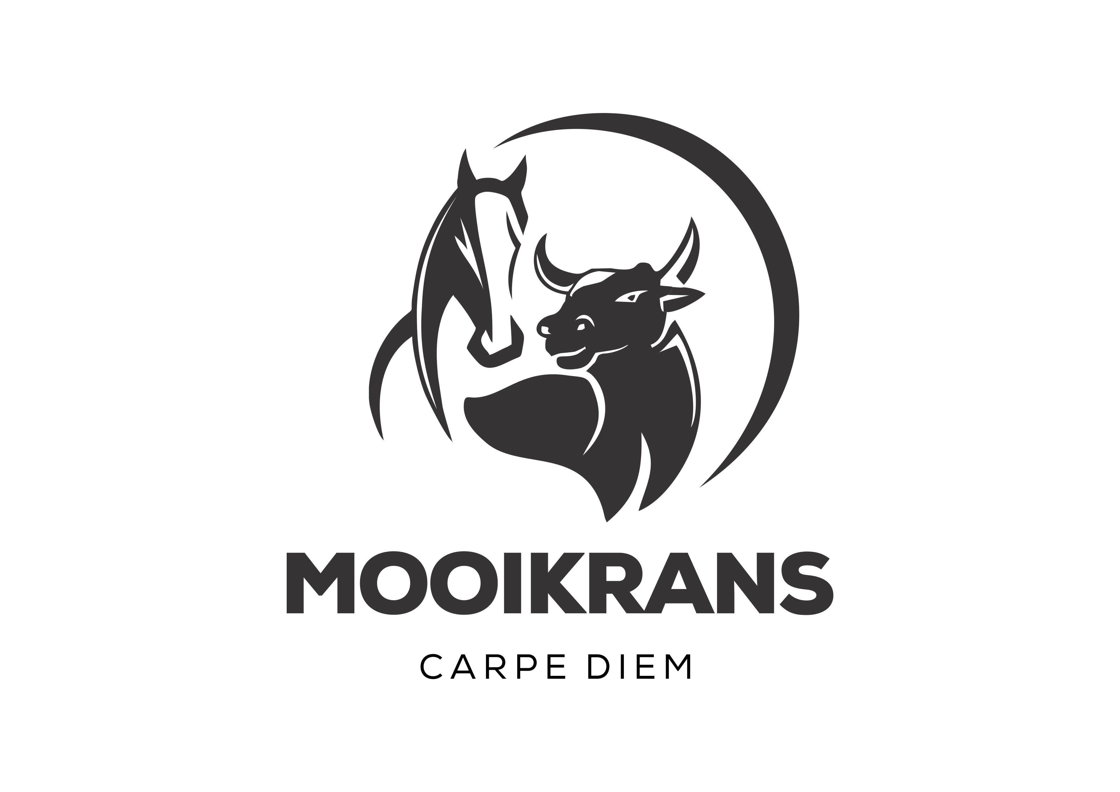
CAMP DATES 2020
Cost per person
MARCH
Farm Holiday Camp 1 | Sunday 22 March – Saturday 28 March | R2 800
 | JUNE/JULY
AUGUST
Private School Camp | Sonday 16 August – Saturday 22 August | R3 000
SEPTEMBER
Farm Holiday Camp 1  Farm Holiday Camp 2 | Friday 25 September – Saturday 3 October  Sunday 27 September – Saturday 3 October | R3 000  R2 800
DECEMBER/JANUARY
Farm Holiday Camp 1 | Sunday 6 December – Saturday 12 December | R2 800
Farm Holiday Camp 2 | Sunday 13 December – Saturday 19 December | R2 800
Farm Holiday Camp 3 | Sunday 6 Desember – Saturday 12 December | R2 800
Farm Holiday Camp 4 | Wednesday 16 December – Tuesday 22 December | R2 800
Farm Holiday Camp 5 | Sunday 3 January – Saturday 9 January | R2 800

Camps can be attended consecutively at an additional cost of R470 per person for each day added to the camp.

